This doc contains the basic of using a program to test a SEN0542 touch sensor
- Download the software from this link: LINK
- Extract and open the software.
- Connect the module via any USB to TTL converter; some options are shown below:
- Basic connection diagram:
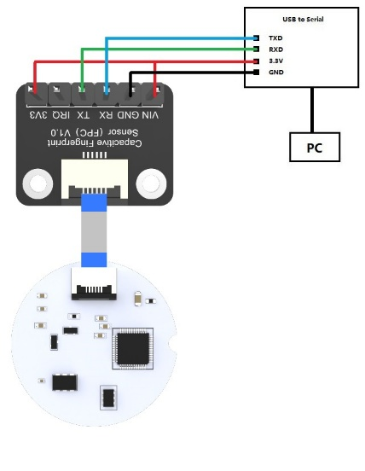
- Connection using USB to TTL with logic level converter by Reyax Technology CP2102:
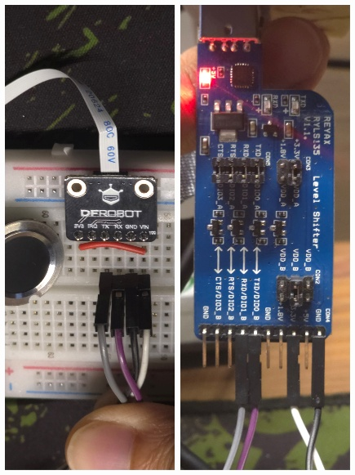
- Connection using USB to TTL converter CP2102:
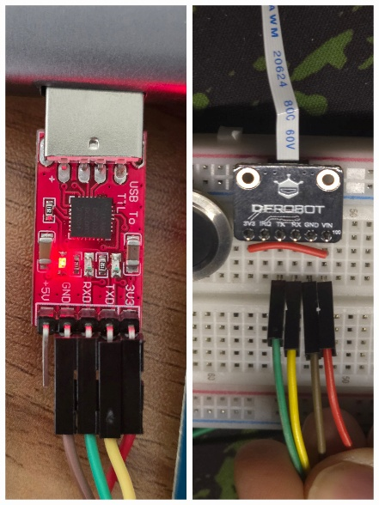
- This is the first page of the software. Translate to English from the right-hand side.
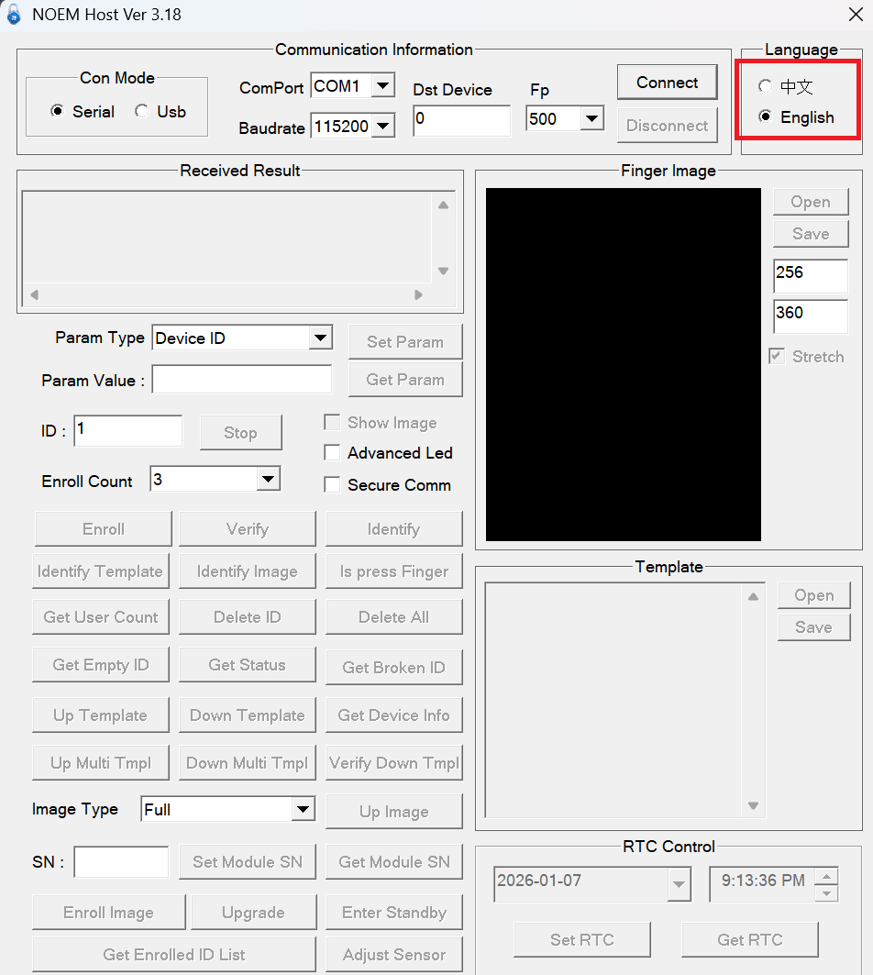
- Connect the USB module with the computer and check for new COM port:
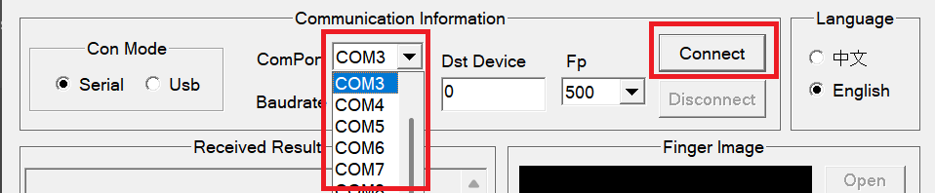
- Upon successful connection, the top part of the screen will look like this:
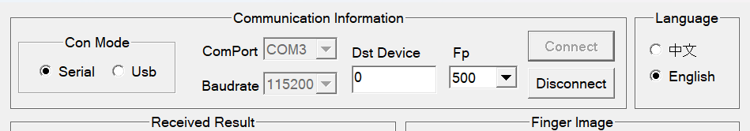
- Initially, the fingerprint sensor does not contain any fingerprints so pressing the button “Get Enrolled ID List”, the result will show enroll count = 0.
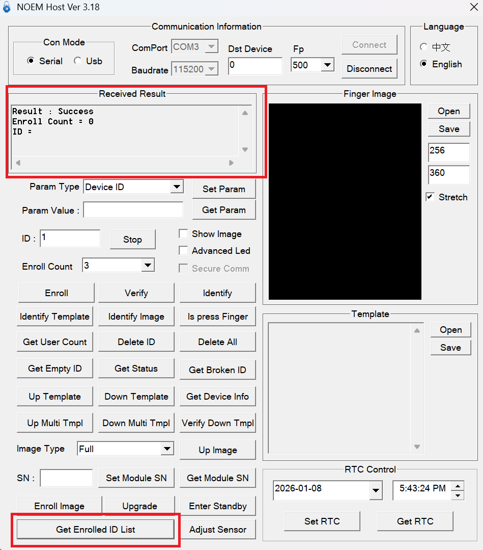
- To enroll a new finger, press the Enroll button. This will store only one finger, but I suggest you select Enroll Count as at least 2 for two enrollments of the same finger for better accuracy.
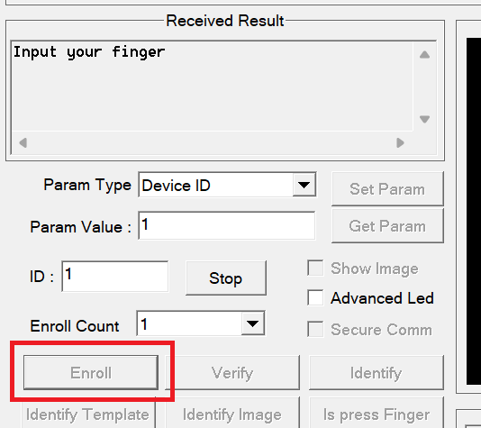
After successful entry of a finger, the output will be:
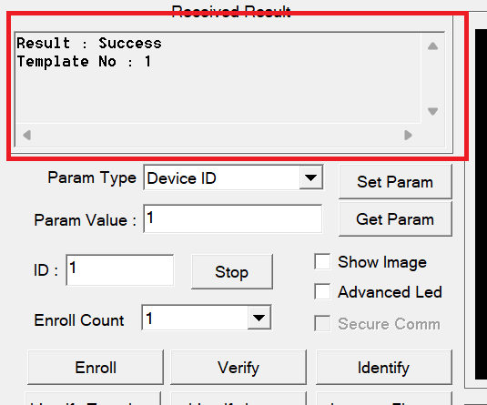
- Done, you have successfully registered a new fingerprint, which will be stored on the fingerprint IC. To verify the enrolled ID, press the “Verify button” and place your finger. It takes less than a second to register the finger. For multiple fingerprints, you need to select the ID of the registered fingerprint for a successful match.
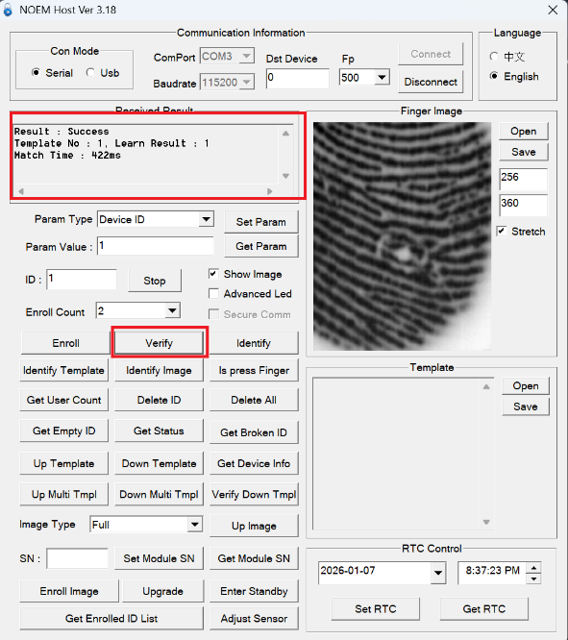
Note that, if the ‘show image’ button is pressed, the software will take a longer time to upload and show the finger image.
- To add multiple fingerprints, adjust the ID value and enroll.
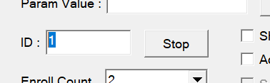
- To delete a specific ID, enter the ID and press “Delete ID”
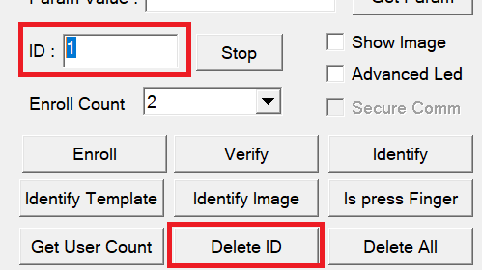
- Other useful features:
- The sensor has a learning feature, so it will continue to learn the enrolled fingerprints.
- The Delete All button deletes all the store fingerprints.
- You can save a finger image and upload it later for verification with store's fingerprints.
- The IRQ button gives a boolean output. Presence of finger outputs around 2.5V and absence outputs 0V.

